**Open port in security group on Oracle cloud compute instance.**

Click on compute under left corner tab

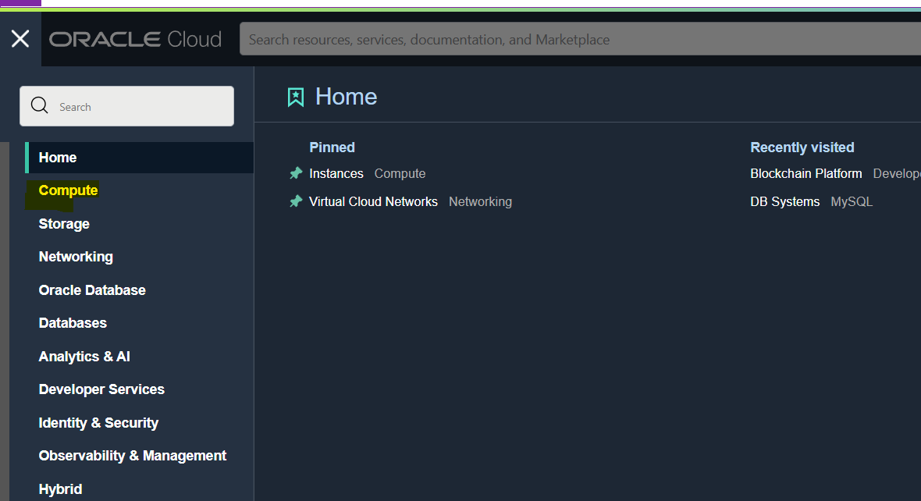

Select instance

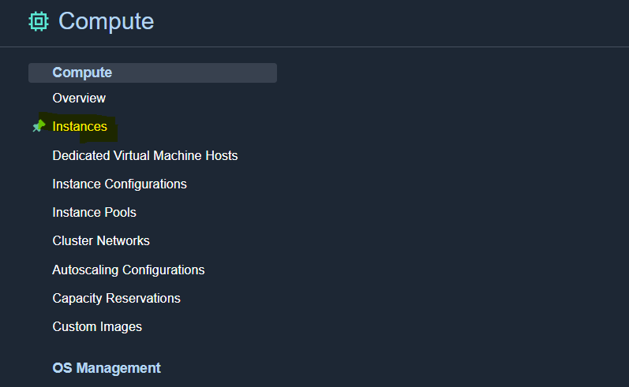

Select instance on that want to open custom port

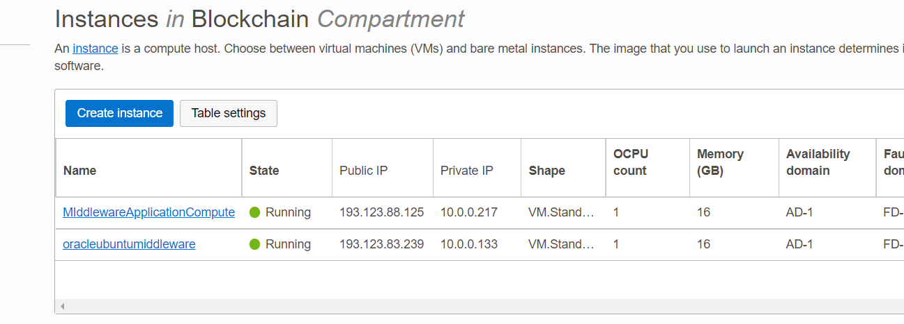

Click on public subnet

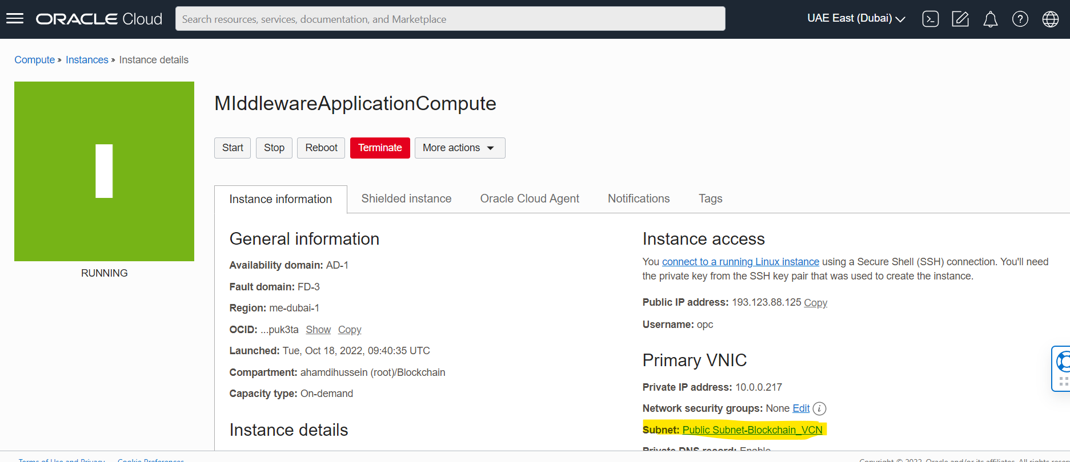

Select security group

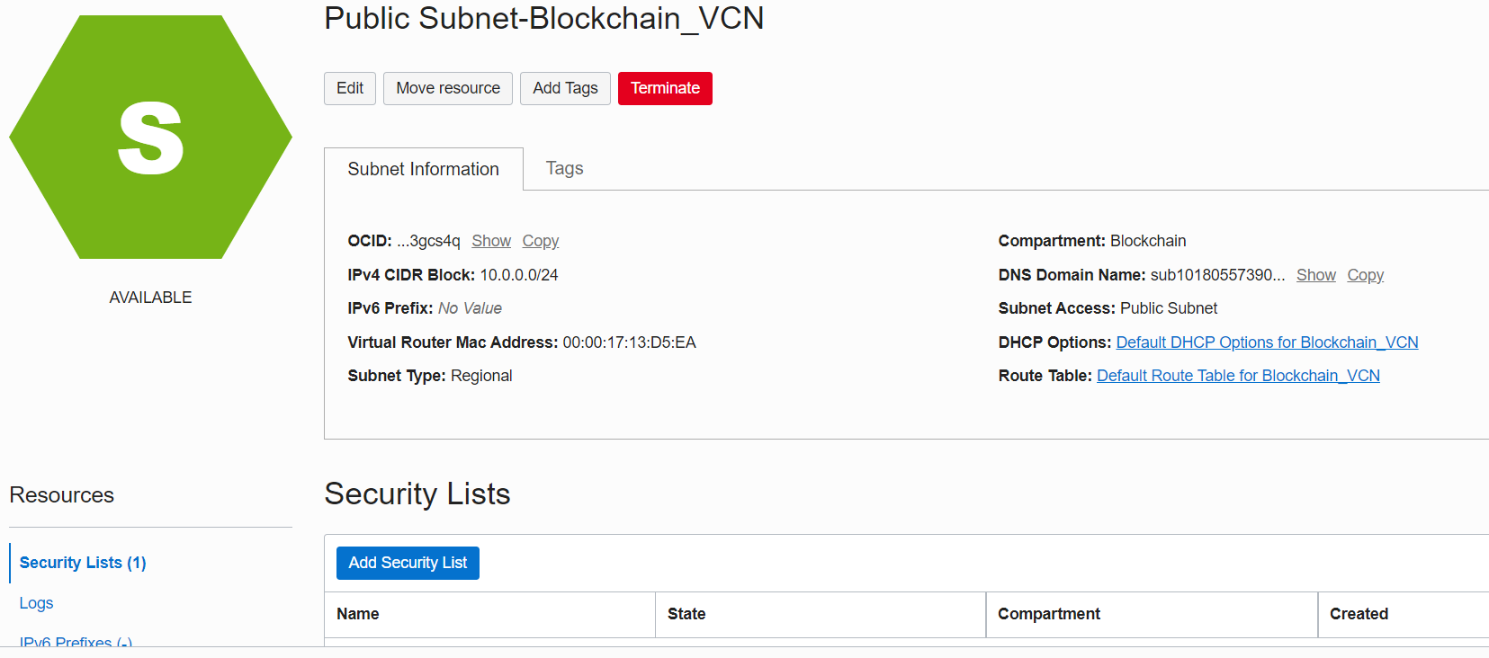

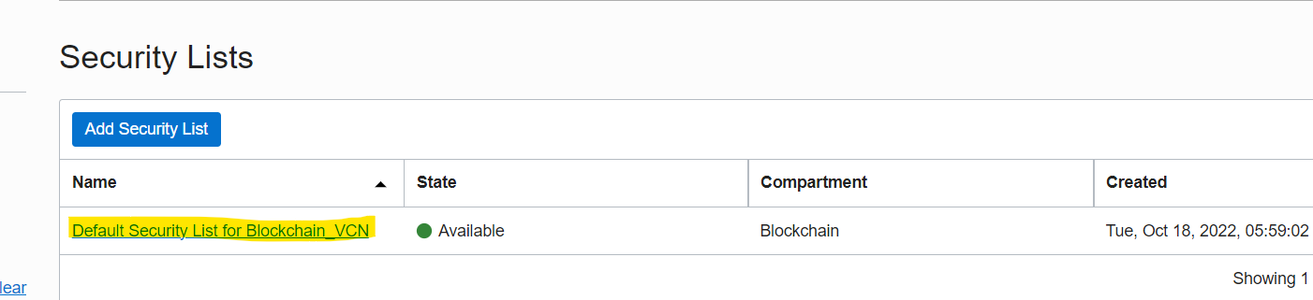

Click on ingress Rules and add the security group rule to enable the port

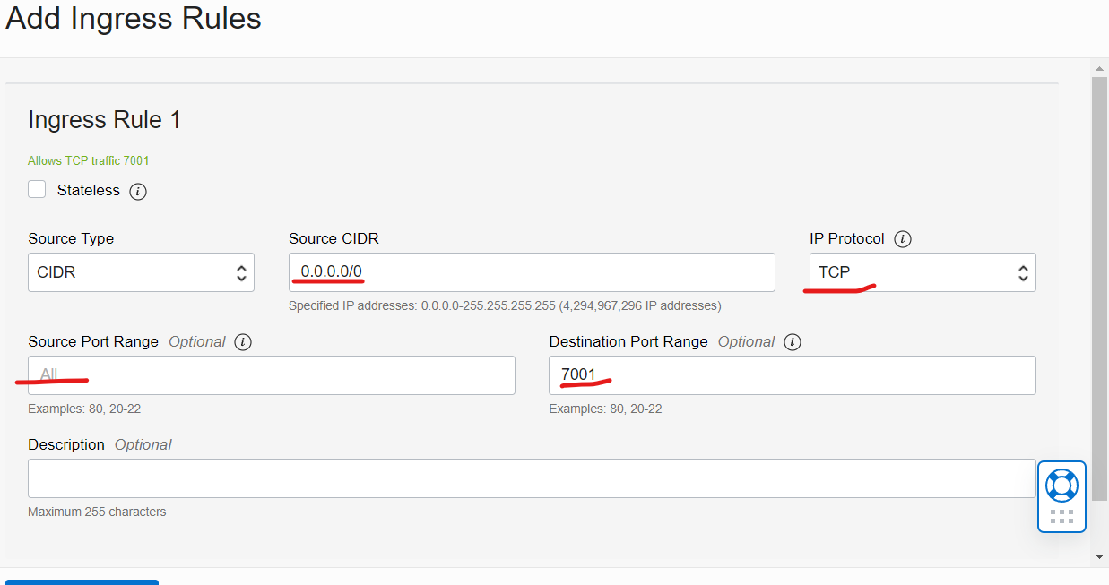

Click on Add ingress Rule

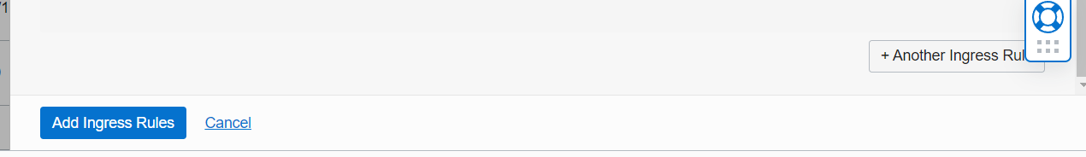

**Open port 7001/7005/ ingress rule in oracle cloud using cli step 5 and 6 is applicable**

1 sudo iptables --list --line-numbers 2 sudo iptables -I INPUT 5 -i ens3 -p tcp --dport 7005 -m state --state NEW,ESTABLISHED -j ACCEPT 3 sudo iptables -I INPUT 3 -i ens3 -p tcp --dport 7005 -m state --state NEW,ESTABLISHED -j ACCEPT 4 sudo firewall-cmd --zone=public --permanent --add-port=80/tcp 5 sudo firewall-cmd --zone=public --permanent --add-port=7005/tcp 6 sudo firewall-cmd --reload 7 sudo firewall-cmd --zone=public --permanent --add-port=3306/tcp 8 sudo firewall-cmd --reload 9 history

[**https://techviewleo.com/how-to-install-mysql-on-oracle-linux-server/**](https://techviewleo.com/how-to-install-mysql-on-oracle-linux-server/)

Install mysql on oracle linux machine/linux/centos

sudo yum update

sudo dnf module list mysql

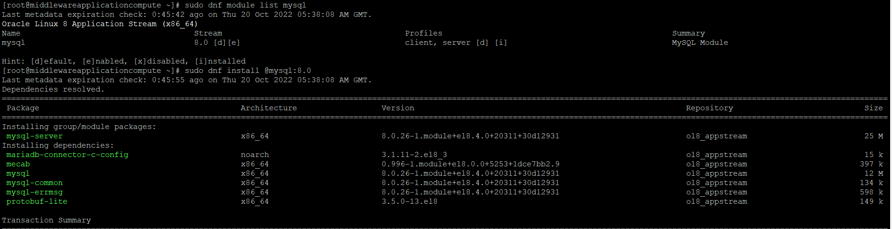

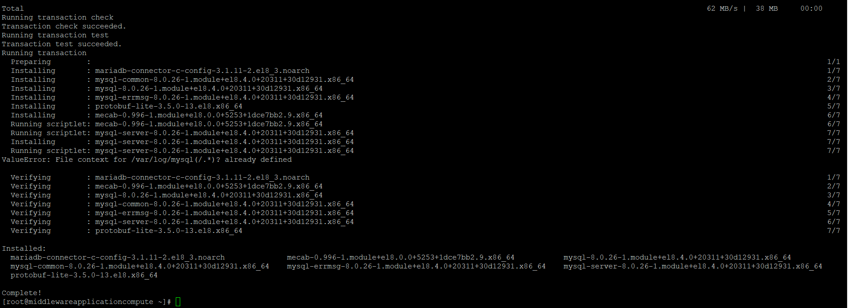

rpm -qi mysql-server

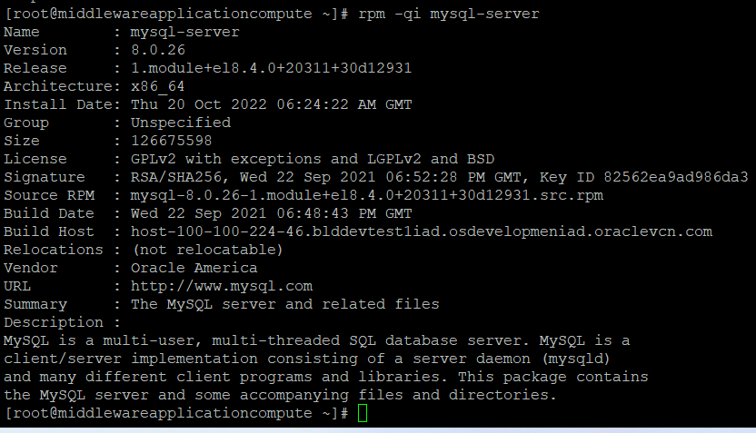

sudo systemctl enable --now mysqld

systemctl status mysqld

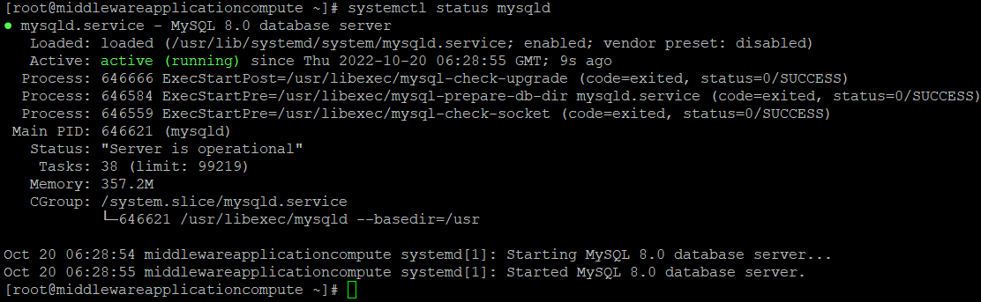

**Add bind address in mysql configuration file**

**vi /etc/my.cnf.d/mysql-server.cnf**

bind-address=0.0.0.0 and save it.

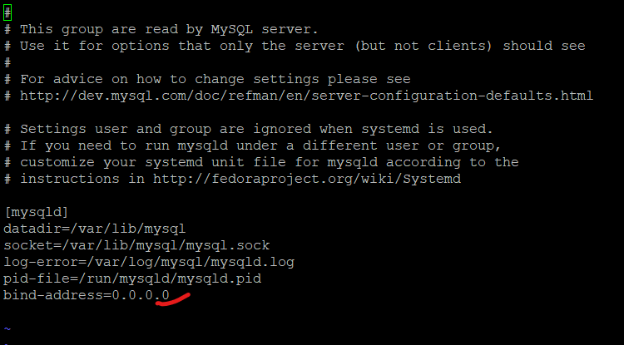

**Open port 7001 ingress rule in oracle cloud using**

sudo firewall-cmd --zone=public --permanent --add-port=7005/tcp sudo firewall-cmd --reload

**Open mysql port 3306 ingress rule in oracle cloud using**

**sudo firewall-cmd --zone=public --permanent --add-port=3306/tcpsudo firewall-cmd –reload**

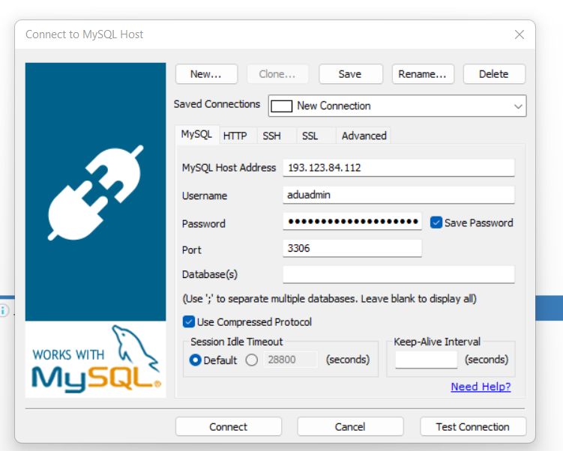

**Now database connection has been established**

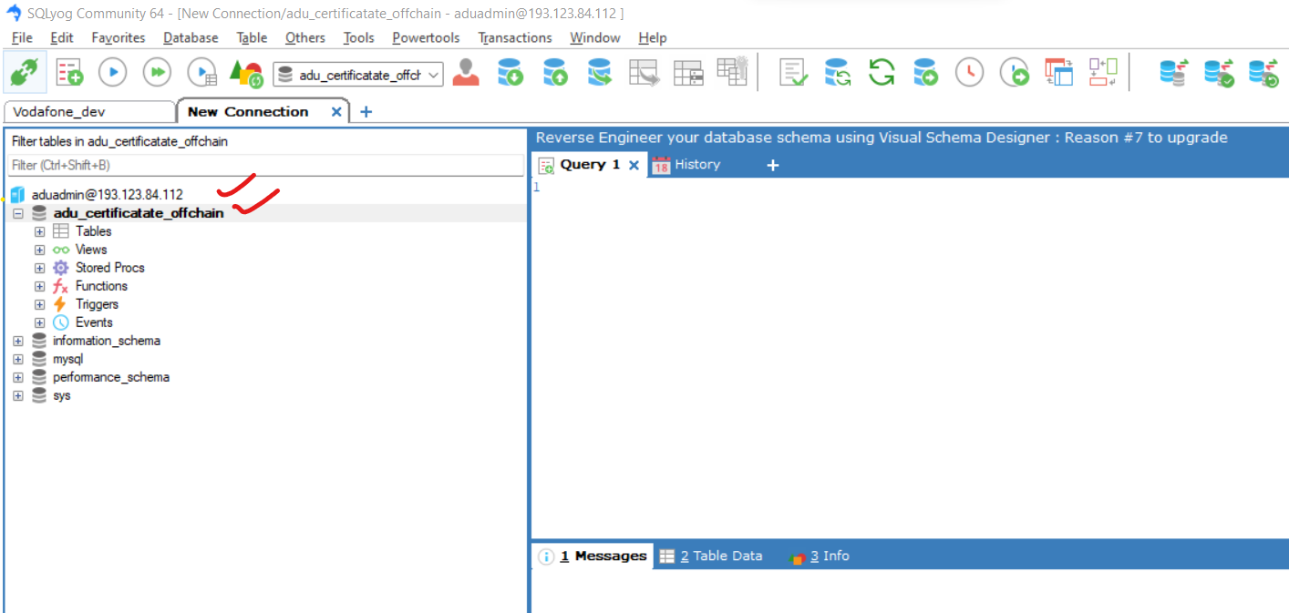

**Install nginx on Oracle Linux 8**

*sudo dnf install -y nginx*

*sudo systemctl enable --now nginx.service*

*sudo systemctl status nginx*



